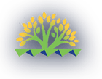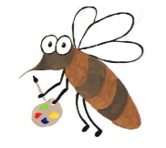

Lyng Primary School Knowledge Organiser

Art

What is the impact of Retrofuturistic art?

Year 5

Topic: Art

Spring

|  |  |
| --- | --- |
| Vocabulary | |
| **Spelling** | **definition** |
| Collagraphy | A print making process that use textures that creates interesting surfaces within a print |
| Decision | After taking different things into account you come to a conclusion |
| Futuristic | An object or image that looks like it’s from the future |
| Imagery | A collection of visual images |
| Propaganda | Information that may be misleading to promote an often political cause |
| Purpose | The reason for something being created |
| Retrofuturism | A vision of what the future might look like created in the pre 1960s |
| Technique | Applying a particular method of making somehting. |

**Background information for parents and teachers**

Children will study the Ancient Greeks who invented astronomy. Linking this to our Science topic of Earth and Space, children will use skills learned through the unit as well as their Space knowledge to create a collagraphy print.

**Children will explore the works of: Peter Thorpe and Teis Albers.**

**Spring term**

Ancient Greece - Space

|  |
| --- |
| Skills and techniques |
| -Develop ideas more independently from their own research. Explore and record their plans, ideas and evaluations to develop their ideas towards an outcome.  -Confidently use sketchbooks for purposes including recording observations and research, testing materials and working towards an outcome more independently.  - Work with a range of media with control in different ways to achieve different effects, including experimenting with the techniques used by other artists.  -Combine a wider range of media, e.g. photography and digital art effects.  -Create in a more sustained way, revisiting artwork over time and applying their understanding of tone, texture, line, colour and form. |

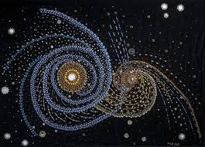

Print making:

Collagraphy (sometimes spelled collography) is a printmaking process in which materials are glued or sealed to a rigid substrate (such as paperboard or wood) to create a plate. Once inked, the plate becomes a tool for imprinting the design onto paper or another medium. The resulting print is termed a collagraph.

Prior knowledge:

In year 4 the children will have experienced print making through block printing for their Anglo Saxon artwork for repeated patterns.

`

Agreed outcome:

Create a Space inspired collagraphy print